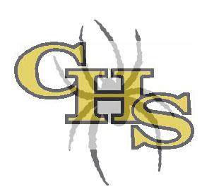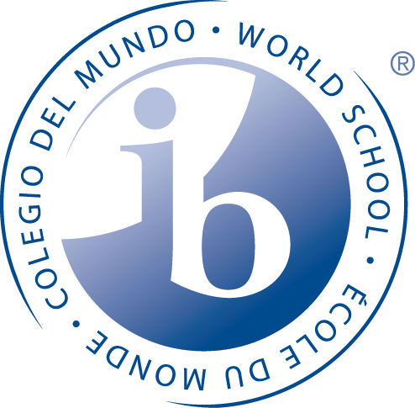
History of the Americas Category II: History 2
Higher Level (HL)
Mr. Rowe
Contact Information:
Email: andrew.rowe@cabarrus.k12.nc.us
Phone: 704-260-6000
Room #: 417
http://rowechsib.weebly.com

Course Description:
History of the Americas is a required course of the International Baccalaureate Diploma Programme (DP) and builds upon prior knowledge and skills from the Middle Years Programme. The course is a component of Group 3, Individuals and Societies, and consists of an intense two year study of the Western Hemisphere from colonization through modern day. Concord High School’s History of the Americas follows the Higher Level (HL) route where students will have a list of prescribed topics that will become the main emphasis in year two.

The first year provides an in-depth look at the initial merging of indigenous American culture, European powers, and African slave trade. Next, the students will study revolutionary movements, nation building, causes and effects of industrialization, and domestic conflicts that make or break nations. Finally, the students will finish the year with an emphasis on the causes and effects of American Imperialism ending with the global conflicts of World War I and World II.

Throughout the year, students will learn and practice historiographical theories and skills in order to prepare students to evaluate historical sources. There will be a variety of formative and summative assessments with the intent of preparing and practicing for the Individual Assessment (internal assessment, IA) and their three essays (external assessments.) See later in the syllabus for a chart explaining the internal and external assessments. The internal assessment consists of a “Historical Investigation” that will align with four objectives listed later in the syllabus as well. The formal assessments will not be administered until the student’s senior year. We will complete versions of the external assessment from the History of the Americas course along with a practice IA as well..

Finally, the History of the Americas course aligns with the Theory of Knowledge course to enhance the fundamental core of the Diploma Programme which includes critical reflecting and analyzing various “ways of knowing” throughout the eras of human science.

IB Mission Statement and the IB Learner Profile
The International Baccalaureate aims to develop inquiring, knowledgeable and caring young people who help to create a better and more peaceful world through intercultural understanding and respect.

To this end the organization works with schools, governments and international organizations to develop challenging programmes international education and rigorous assessment.

These programmes encourage students across the world to become active, compassionate and lifelong learners who understand that other people, with their differences, can also be right.

IB Learner Profile Characteristics
- Inquirers
- Knowledgeable
- Thinkers
- Communicators
- Principled
- Open-Minded
- Caring
- Risk Takers
- Balanced
- Reflective

Group 3, History of the Americas: Higher Level (HL)
Taken from the IB History Guide found in the “Online Curriculum Center”

“Nature of the Subject”
History is a dynamic, contested, evidence-based discipline that involves an exciting engagement with the past. It is a rigorous intellectual discipline, focused around key historical concepts such as change, causation and significance. History is an exploratory subject that fosters a sense of inquiry. It is also an interpretive discipline, allowing opportunity for engagement with multiple perspectives and a plurality of opinions. Studying history develops an understanding of the past, which leads to a deeper understanding of the nature of humans and of the world today. The IB Diploma Programme (DP) history course is a world history course based on a comparative and multiperspective approach to history. It involves the study of a variety of types of history, including political, economic, social, and cultural, provides a balance of structure and flexibility. The course emphasizes the importance of encouraging students to think historically and to develop historical skills as well as gaining factual knowledge. It puts a premium on developing the skills of critical thinking, and on developing an understanding of multiple interpretations of history. In this way, the course involves a challenging and demanding critical exploration of the past. There are six key concepts that have particular prominence throughout the DP history course.

Group 3 Aims
The aims of all subjects in group 3, individuals and societies are to:
- Encourage the systematic and critical study of: human experience and behavior; physical, economic and social environments; the history and development of social and cultural institutions
- Develop in the student the capacity to identify, to analyze critically and to evaluate theories, concepts and arguments about the nature and activities of the individual and society
- Enable the student to collect, describe and analyze data used in studies of society, to test hypotheses and interpret complex data and source material
- Promote the appreciation of the way in which learning is relevant to both the culture in which the student lives and the culture of other societies
- Develop an awareness in the student that human attitudes and opinions are widely diverse and that a study of society requires an appreciation of such diversity
- Enable the student to recognize that the content and methodologies of the subjects in group 3 are contestable and that their study requires the toleration of uncertainty
History aims: The aims of the history course at SL and HL are to:
- Develop an understanding of, and continuing interest in, the past
- Encourage students to engage with multiple perspectives and to appreciate the complex nature of historical concepts, issues, events, and developments
- Promote international-mindedness through the study of history from more than one region of the world
- Develop an understanding of history as a discipline and to develop historical consciousness including a sense of chronology and context, and an understanding of different historical perspectives
- Develop key historical skills, including engaging effectively with sources
- Increase students’ understanding of themselves and of contemporary society by encouraging reflection on the past
The Concord High School IB Program has chosen the following pathway for your studies throughout the your two years.
Prescribed Subject | World History Topics | HL Option | Internal Assessment
The Move to Global War | Topic #10 Authoritarian States  Topic #12 The Cold War: Superpower Tensions and Rivalries | #6 Independence Movements (1763-1830)  #7 Nation-building and challenges (1780-1870)  #8 United States’ Civil War: Causes, courses, and effects (1840-1877) | Student chooses any historical topic to investigate, for example, preferably from a topic covered in either year 1 or 2.
IB Diploma Assessments:
IB HL 2 year History Programme assess IB students within their senior year. These are two Internal Assessments (IA), the Historical Investigation that count for 20% towards their IB Diploma grade. There are three timed examinations, Paper 1, Paper 2, and Paper 3 that seniors sit for in May which count for 80% of their Diploma grade. Paper 1 (20%) and Paper 2 (25%) focus on content of the senior year, 20th Century Topics, and Paper 3 (35%) focuses on content of the junior year, HOTA. All IB assessments reflect in both junior and senior year reflect the IB Assessment nature and goals of knowledge and understanding: application and interpretation; synthesis and evaluation; and utilization of historical skills

In the DP, as well as in the Primary Years Programme (PYP) and Middle Years Programme (MYP), these cognitive, metacognitive and affective skills are grouped into the same five ATL categories.
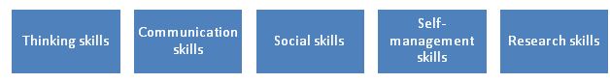

History of the Americas Unit Planner
Topic 1: Indigenous Societies and cultures August 23-September 8
Topic 2: European Exploration and conquests September 9- October 13
Begin Practice Internal Assessment October 14-October 21
Topic 6: Independence Movements October 22-January 13
Topic 7: Nation-building and challenges January 19-March 16
Topic 8: US Civil War; causes, courses, effects March 17-May 23
Practice Internal Assessment due May 23, 2022

Grading Policy:

- Tests & Projects: 55%
- Classwork assignments: 15%
- Quizzes: 30%

Work Submission & Late Work & Absences:
- Most work will be submitted through Canvas, please follow along with the modules and my website which has the daily calendar. If you have any questions, please ask. Late work will be accepted but with a late penalty. I will work with you on due dates if circumstances warrant but I know ahead of time not on the due date.
- Likewise if you are absent, the work will be on Canvas and/or my website for you to keep up with and submit. Deadlines for assignments when a student is absent will be determined by me.

General Expectations:

- Be on time- please take care of bathroom, water, and grooming needs before class. NO hall passes will be given during the first and last 10 minutes of class.
- Be respectful of everyone’s opinions and viewpoints in the classroom. THERE WILL BE NO TOLERANCE OF RACIST, SEXIST, OR HOMOPHOBIC comments or actions in my class.
- Be prepared: you need the right attitude, an open mind, and the right materials
- Be responsible, keep up with your assignments. (late work will be penalized a letter grade a day).
- Stay organized: we cover several topics at once and assignments will overlap
- Communication: ask questions if things are unclear
- NO CELL PHONES unless permission is given, laptops will be used but for the appropriate reasons and times. Failure to do so will result in school approved consequences.

Honor Code:

All individual assignments are to be completed individually. Students should feel free to conference with one another to explore ideas, but ultimately, work turned in for teacher review should be the work of one student. Examples of violations to this policy include (but are not limited to) giving or receiving help on any in-class or take-home test, essay, or quiz, plagiarism of material on take-home essays, and discussion of any quiz, test, or essay questions with students who have not yet completed that assignment.

*Plagiarism: Plagiarism is using another person’s thoughts and accomplishments without proper acknowledgment or documentation. It is a serious breach of academic integrity. In keeping with school policy, students will receive a zero for the first offense of plagiarism and the offense will go on record. The second offense results in loss of credit.

The Dropout Prevention/Driver’s License legislation from the State of North Carolina requires that CHS is to notify the Department of Motor Vehicles when a student is not making adequate academic progress or drops out of school. “Adequate academic progress” is defined as having passing grades in 70% or more of a student's classes during each semester. A student on the 4 X 4 block (Cabarrus County High Schools) will have his/her license or permit revoked if the student does not pass at least three (3) courses during a semester.

Students who drop out of school and are not making adequate academic progress will also have his/her license or permit revoked. A new Driving Eligibility Certificate cannot be granted for a period of six-months even if the student enrolls in a non-public school or community college.

Respect
Respect is very important to my class. We discuss very controversial issues with a wide array of viewpoints and beliefs. The rule to remember here is that you DO NOT have to agree with me or anyone else in class, but you may NOT disrespect someone because he or she sees things differently. Any disrespectful behavior, which includes disruption, will result in parental contact and possibly administrative action if warranted or behavior continually happens

Classroom Needs
- A composition notebook or some other easily accessible binder for taking and storing notes, articles, etc.
- Something to write with everyday. I am not an office supply store, you will not be able to count on the fact that I’ll have something to loan or give to you. If you can keep track of your phone each day without leaving it at home, I have full confidence that you can do the same with a pen or pencil.

All students are expected to follow the CHS student handbook guidelines as well as the expectations instituted by the International Baccalaureate program.

If at any point throughout the year you have questions or concerns, please do not hesitate to contact me, email works the best. I will usually respond as quickly as I can during normal school hours but please be mindful that during evenings and nights I have family and other aspects of my life that I attend to. I’m excited for a great year.

Mr. Rowe

